Export the digital certificates from the Talemetry Service

- Navigate to https://api.talemetry.com using any web browser (screenshot show chrome)

- Select the security button to the left of the link and click on Connection is Secure and click on Certificate is Valid

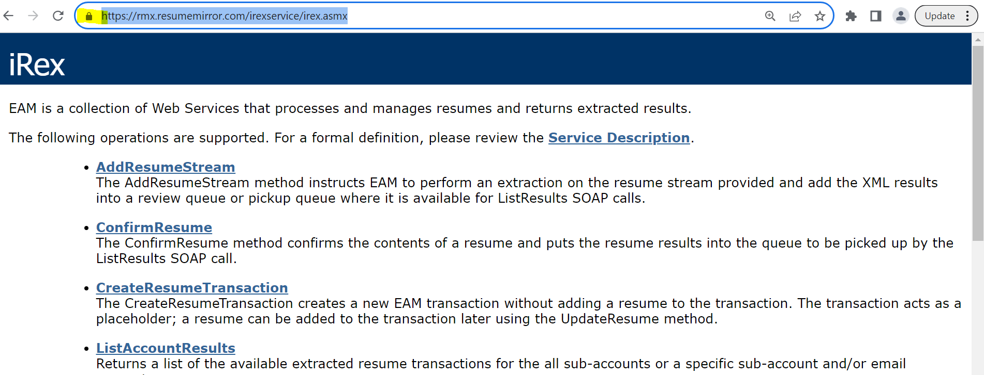

- From the certificate window, Click on Details and Select DigiCert Global Root G2
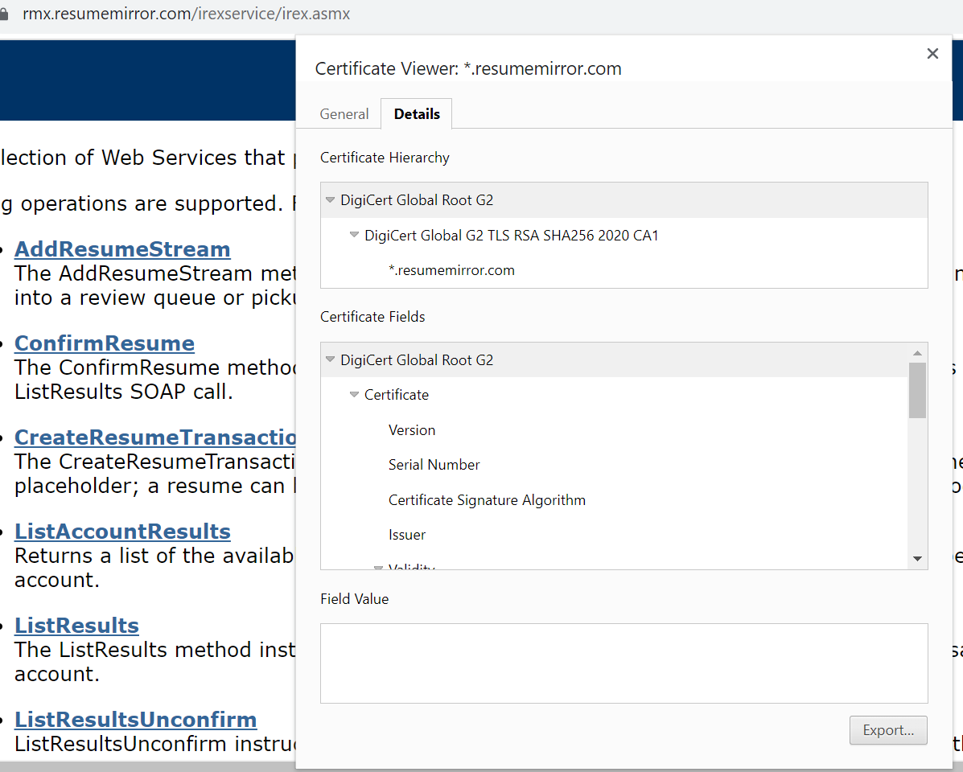

- Click on Export button and save it as Base64-encoded ASCII, single Certificate .
Make sure you change the extension to .cer as shown in below screenshot.

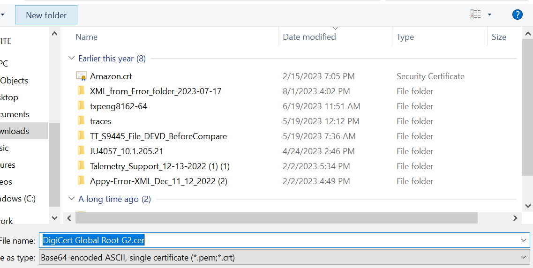

- Repeat the above process for Intermediate certificate DigiCert Global G2 TLS RSA SHA256 2020 CA1 and _.resumemirror.com certificate also.
- You will have 3 .cer files saved by now.

