Export the digital certificates from the Talemetry Service

- Navigate to https://api.talemetry.com using any web browser (screenshot show chrome)

- Select the security button to the left of the link and click on Connection is Secure and click on Certificate is Valid

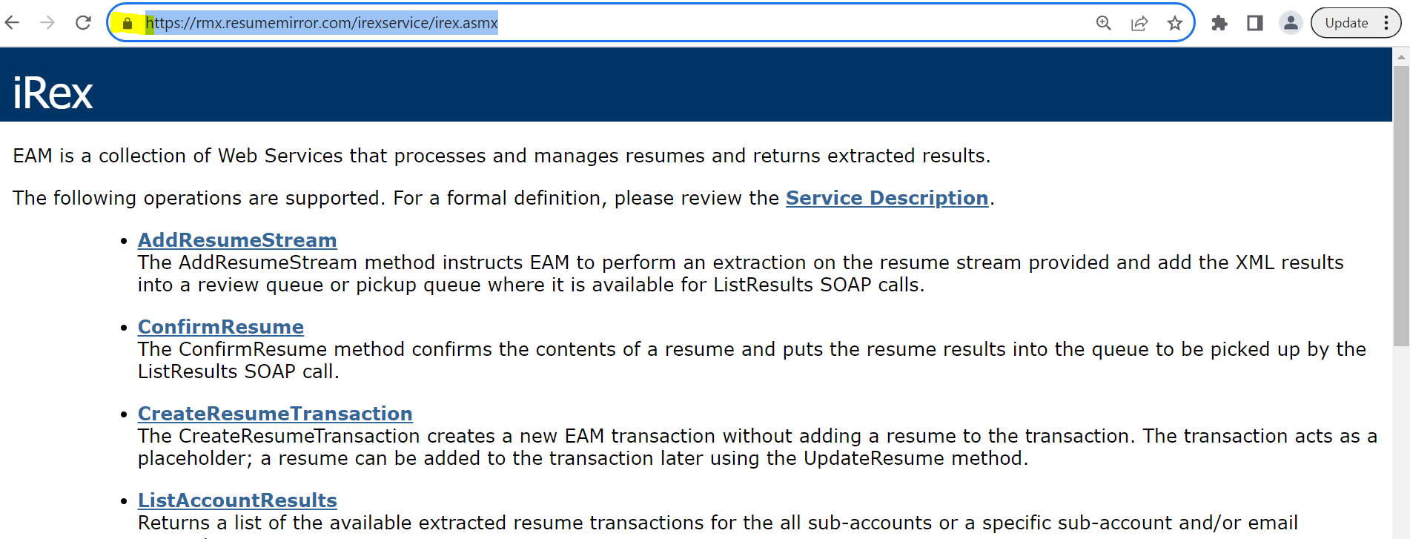

- From the certificate window, Click on Details and Select DigiCert Global Root G2
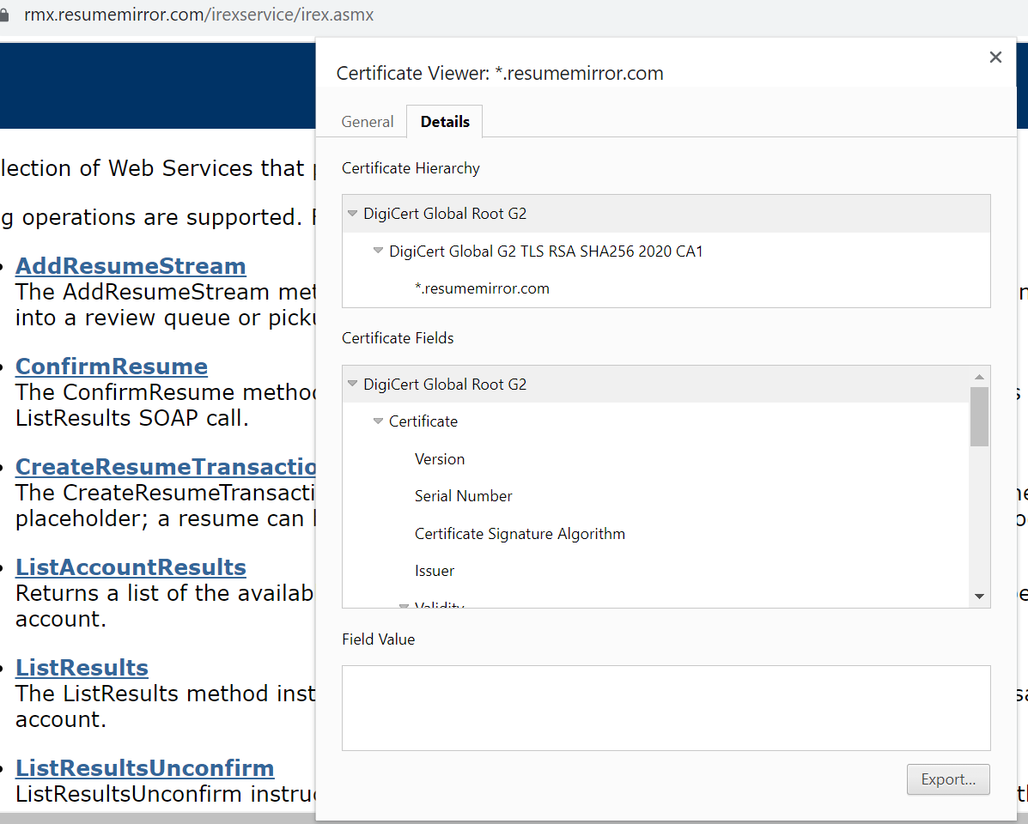

- Click on Export button and save it as Base64-encoded ASCII, single Certificate .
Make sure you change the extension to .cer as shown in below screenshot.

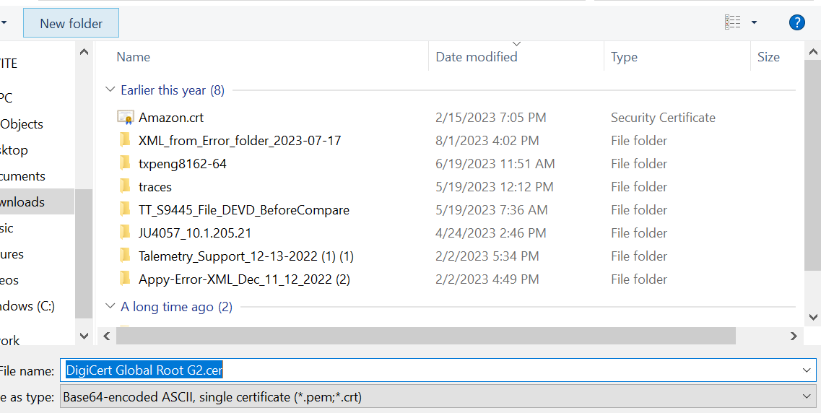

- Repeat the above process for Intermediate certificate DigiCert Global G2 TLS RSA SHA256 2020 CA1 and _.resumemirror.com certificate also.
- You will have 3 .cer files saved by now.

Load the certificates into the PS keystore.

Note: below screenshot’s may look different in your Peoplesoft environment, they are just for illustration purpose only

Navigate to your PeopleSoft keystore directory on your webserver and execute the command pskeymanager.cmd –list

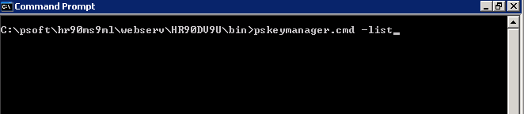

You will be asked for the keystore password ( default is password)
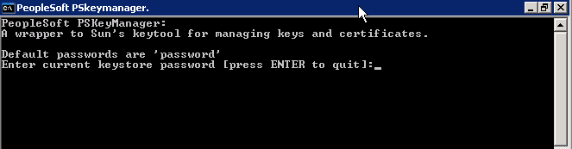

Once you have entered your password, the default certificates will be displayed.
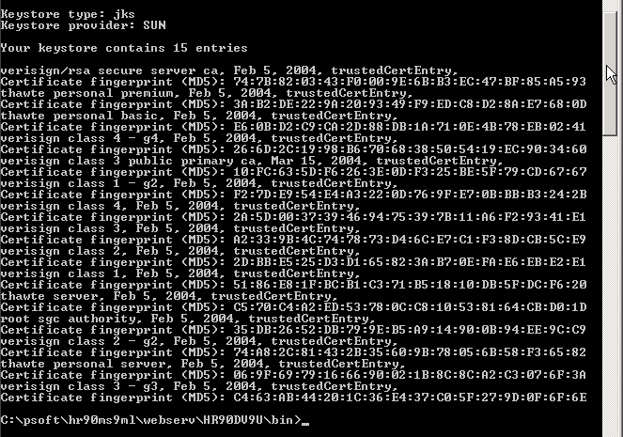

We now need to load the 3 certificates you exported earlier :

You will need to load the Amazon Root CA1.cer and Amazon.cer and .talemetry.cer files into the keystore. Move these three files onto the web server in an accessible directory.

Now run the pskeymanager process and import a certificate
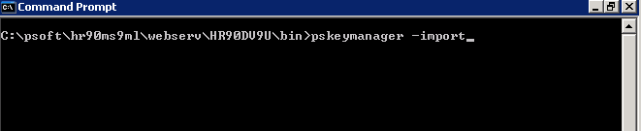

You will be asked for the password:
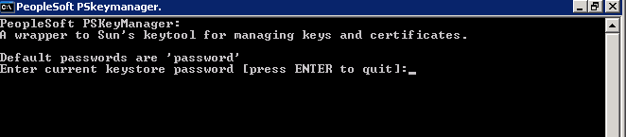

You are then asked for an alias. Please enter the alias as the filename for each of the certificates e.g. for this first load, we will use Amazon Root

Now enter the filename of the .crt file. In this example, the full file path has been used:

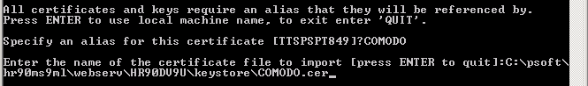

Finally, you are asked to trust this certificate. Please type ‘yes’ here and hit return.

You will receive a final message indicating that the certificate was added to the keystore:
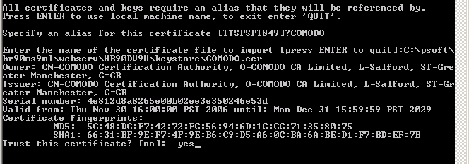

You may confirm that this certificate is displayed by using the command ‘pskeymanager –list’

Please add the other other 2 certificates in the same manner. Once complete, you may execute ‘pskeymanager -list’ and confirm.

Please restart your web server and then retest connectivity.

